CS403 – Introduction:

Lecture – 01: Introduction

- Understand the definitions of a database.
- Had a brief look on file processing system or environment.
- Take a look on some advantages of database.

Lecture – 02: Advantages of DBMS and its users.

Some concepts of database:

Schema:

A database schema defines how data is organized within a relational database; this is inclusive of logical constraints such as, table names, fields, data types, and the relationship between these entities. It is considered as a blueprint of a database which describes how the data may relate to other tables or other data models. However, the schema does not actually contain data. The process of database schema design is also called data modeling.

Database applications.

Database management system (DBMS).

Benefits of DBMS:

- Data consistency.

Data consistency means making sure that the information in a database is accurate, reliable, and stays valid, especially when you are making changes to it. It is like a keeping your data in a good shape and ensuring it follows the rules you have set for it.

- Better data security.
- Faster development of new applications.
- Economy of scale.
- Better concurrency control.

Disadvantages of DBMS.

- Higher cost.
- Conversion cost.
- More difficult to recover.

Data is an resource:

Resource:

Any asset that is of value to an organization and that incurs cost.

Levels of data:

1. Real world data.
2. Metadata. (The data about data.)
3. Data occurrences.

Database users:

- Application programmers.
- End user. (Naive users or normal persons and sophisticated users.
- DBA (Database administrator).

Functions of DBA:

- Schema definition.
- Granting data access.
- Routine maintenance (Backups, monitoring disk space, monitoring jobs running.)

Lecture – 03: Database architecture 1.

Three level architecture:

Objective.

Separate users view from the physical representation.

Why?

- Different views of same data.
- Consolidated representation.
- Both ways easy change.
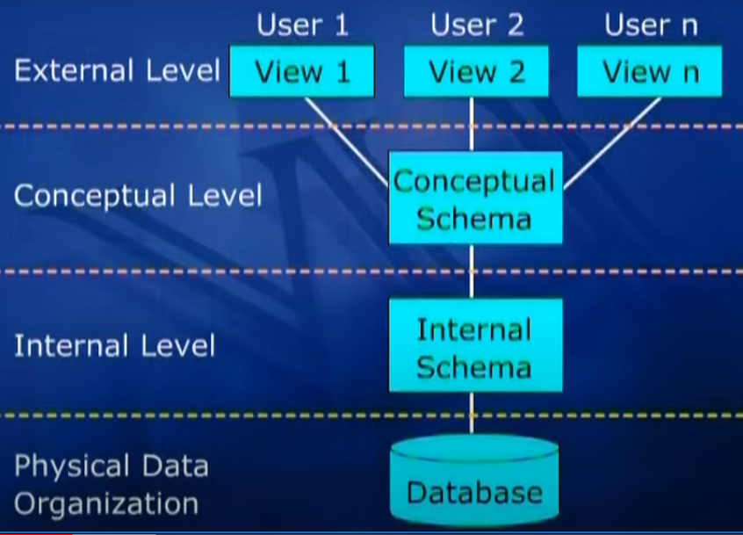

The architecture:

- Depicted by three schemas or three modals.
- Refers to the permanent structure or intention of database.

01) Level 1: External level or External view.

2) Level 2: Logical or conceptual view:

Lecture – 02: Database architecture 2.

Inter-Schema Mapping:

- Also a part of 3 level architecture.
- There are two types of mapping in 3 level architecture.
- 1) External/Conceptual Mapping.
- 2) Conceptual/Internal Mapping.
- BH => Block header and RH => Record header

Data Independence:

Some major benefits:

- Data and application program are independent to each other. Changes in one of them may not cause the loss of other.
- Changes in lower level do not affect the upper levels.
- Do not take it word to word.
- Mind the direction please.

There are two types of data independence.

- Logical Data Independence.
Types of changes:

- Adding a new file of index etc.
- Adding a new field in a file.
- Changing type/size.
- Deleting an attribute.

- Physical Data Independence.

Functions of DBMS:

DBMS performs various types of functions:

- Managing the users.
- Managing the data.
- Data processing.
- A user accessible catalog.
- Transaction support.
- Concurrency control services.
- Recovery services.
- Authorization services.
- Support for data communication.
- Integrity services.

DBMS Environment:

There are commonly two types of DBMS environment:

- Single user environment.
- Multi user environment.

There are different types of multi users environment.
1) Teleprocessing environment:


2) File server environment:

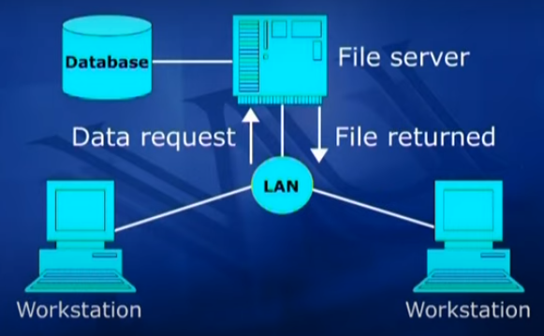
3) Client – Server environment:

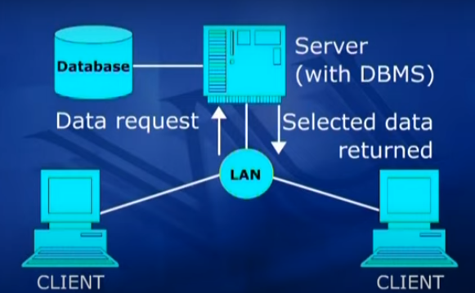
Lecture – 05: Database Application Development Process.

Database application development process involves the following:

- Database design.
- Application program.
- Implementation.

Database Design:

- A database design is a model of a particular real-world system.
- It provides a picture of reality.
- Should be simple and self-explanatory.

Database Development Process:

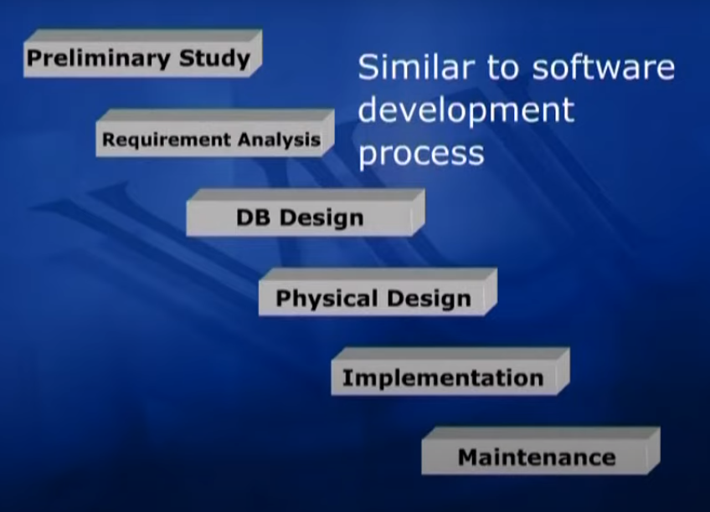
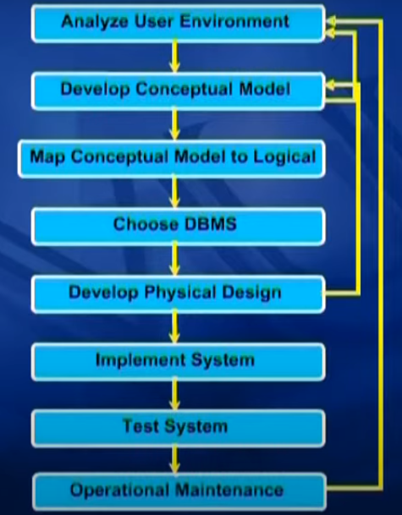

DFD (Data Flow Diagram):

It represents the flow of data between processes within a system.

Dataflows:

Pipeline through which packets of information flow. Arrows are labeled with name of the data that moves through.


Data Store:

- Repositories of data in system.
- Static data.
- Data held for processing.
- Name is a noun phrase.



Process:


Transform incoming data flow into outgoing data flow.
The technique of processing is the below:

- Numbered
- Name is verb/object phrase;
- Noun for high-level systems

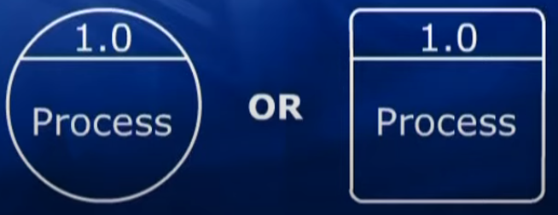
External Entities:

- Sources/destinations for data.
- Outside the system.

- Name is noun phrase
Collector:

- Several data flows combine here.
- No processing occurs here.


Separator:

- Several data flows split from here.
- No processing.

Ring-sum operator:

- Shows two possible data flows.
- Only one is followed.


AND operator.

- Shows two data flows
- Both are followed.

Types Of DFD:

There are three types of DFD.

- Context diagram.
- Level 0 diagram (Also known as level not diagram)
- Detailed diagram.

Context Diagram:

- Consist of single process/system.
- Represent the system/process being analyzed.
- Name: Usually a noun phrase.
- Show context only.
- Inputs/outputs.
- External entities.
- No data stores.
- No flows between external entities.

Diagram:

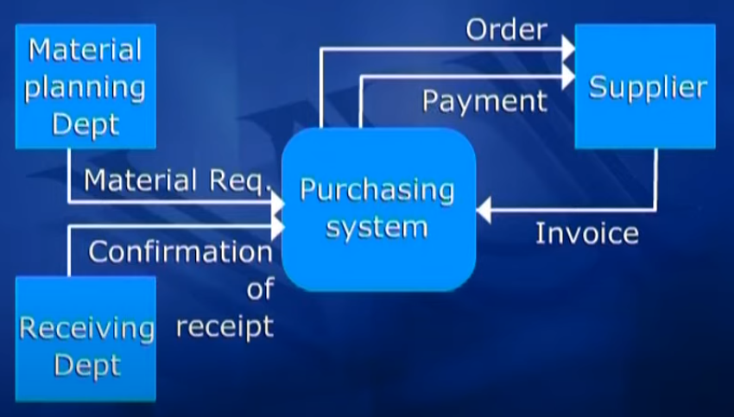
Level 0 Diagram:

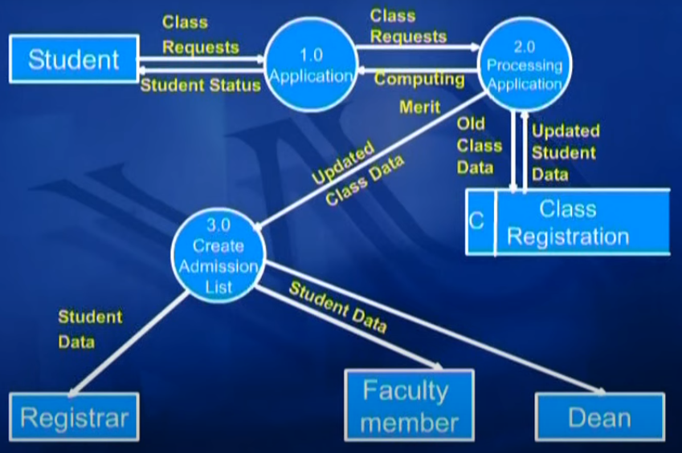
Lecture – 06: Detailed Diagram and Database Design:

Detail Diagram:

- Show processes in successive levels of detail.
- Shows major sub-processes.

Data Dictionary:

- Maybe integrated or freestanding.
- Integrated is referred by DBMS.
- Freestanding as a case tool.

Cross Reference Matrix.

- A data dictionary tool. (Freestanding)
- Used to link different things, like function to entities, or requirements to attributes.
- Can be manual even.
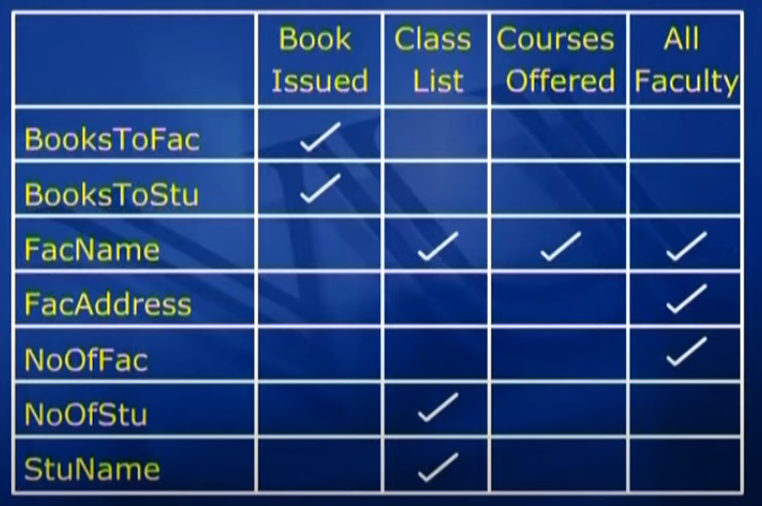

Database Design Phase:

- Design and model mean the same.
- Database Design represents logical structure of the database.

Database Modeling or Database Designing:

- Process of creating a logical representation of the structure of the database.
- The most important task in database development.
- A database must mirror the real world. Only then it can answer questions about the real world.
- The emphasis of data modeling is to represent reality.
- Ideally it should be represent graphically.
- The goal is to identified the facts to be stored in the database.
- Data modeling involves users and analysts.
- Created using a data model.
- Data Model: It is a set of tools or constructs that is used to construct a database design.

Components of Data Model:

- Structures.
- Manipulation language.
- Integrity Constraints.

Significance of data model:

- Facilitates and provides guidelines or rules in the DB design process.
- Every DBMS is based on a DM.

Types of Data Model:

- Semantic : Entity-Relationship, Object-Oriented
- Record Based: Hierarchical, Network, Relational.

Database Design Types:

- Conceptual DB Design: Using SDM (Sematic Data Model)
- Logical: Using DM of tool.
- Physical: Using the DBMS.

Lecture: 07 – Entity-Relationship Data Model:

E-R Data Model:

A sematic data model used for the graphical representation of the conceptual database design.

Major Components:

- Entities.
- Attributes.
- Relationships.

Different meanings of entity:

- Entity type.
- Entity instance.
- Entity set.

Entity Type:

- A name or label assigned to the items or objects that exist in an environment and that have similar properties.
- It could be person, place, event or even concept.
- Differentiate from other entity types on the basis of environments.
- Identified through abstraction process.

Gate Smashers DBMS:

Basic Introduction:

- 3 schema, 3 level of abstraction => Data Independence.
- Various data models:
  - Network data model.
  - Hierarchical.
  - Relational data model.
  - ER data model.
  - Object-Oriented.
- ER Model:
  - Attributes.
  - Relationships and their types.
- Basics of keys:
  - Primary key.
  - Candidate key.
  - Super key.
  - Foreign key.
- Normalization:
  - Closure method.
  - Functional dependency.
  - 1NF, 2NF, 3NF, BCNF (Normal Forms).
- Transaction control and concurrency:
  - ACID properties.
  - Read write.
  - Write read.
  - Write write
  - Conflict serializabilty.
  - Recoverability.
  - 2PL (2 Phase Locking), time stamp.
- SQL and Relational algebra.
  - DDL commands.
  - DML commands.
  - DCL commands.
  - Constraints.
  - Aggregate functions.
  - Joins
  - Nested query.
    - In
    - Notin
    - Any
    - All
- Indexing:
  - Primary.
  - Cluster.
  - Secondary.
  - Btree
  - B+tree

